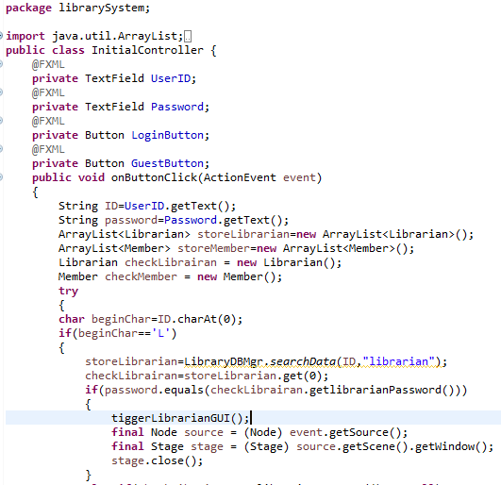

If password equals data’s record, execute its own method.

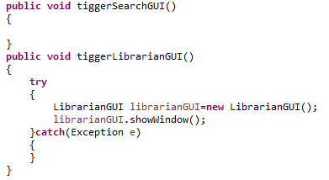

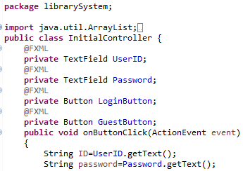

Class InitialController create object UserID & Password itself, then it can use getText() in its method.

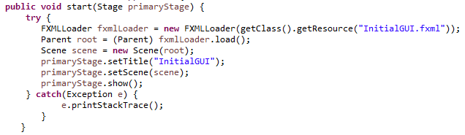

Method get object primaryStage as parameter, so it can use show() method which comes from primaryStage.

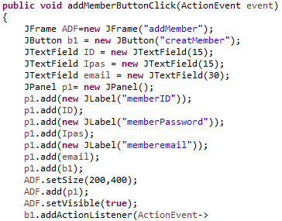

When addMemberButtonClick method execute, it will create object and use its method